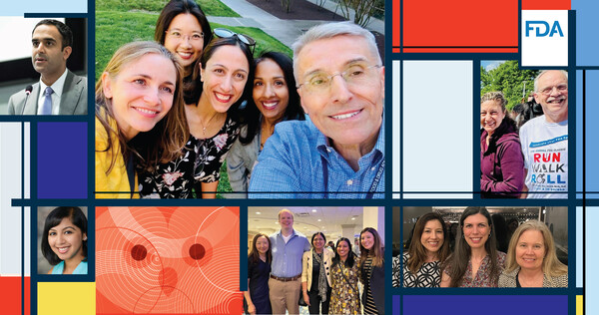
  The OCE Owl
  August 2023

Greetings from FDA Oncology

Ever wonder who works in oncology at the FDA? Or what happens behind the scenes?
We are a diverse group of over 100 oncologists and are excited to introduce ourselves, explain what we do, and engage with you!

This newsletter provides a summary of FDA Oncology Center of Excellence (OCE) upcoming public events, educational opportunities, and recent oncology product approvals. Events are free and everyone is welcome to attend — we hope to see you there!

Please share this newsletter with your hematology/oncology fellows, faculty, staff, and anyone interested in learning more about what we do at the OCE!

Upcoming Public FDA Oncology Events
September 6-7, 2023: Second Annual FDA ASCO Workshop on Getting the Dose Right. Meeting & Registration Information.
Watch on YouTube: Conversation on Cancer: National Black Family Cancer Awareness Week – Engaging the Generations public panel discussion.
Watch on YouTube: Conversations on Cancer: Cancer Misinformation:Truth or Consequences
For a full list of our past and upcoming meetings and workshops, check out this website:
OCE Meetings and Workshops.

Project Socrates: Educational Opportunities
OCE has many free educational programs for hematology/oncology fellows, junior faculty, basic and translational scientists, and anyone interested in learning more about regulatory science and drug development. This includes workshops, fellowships, and webinars. Check out our Project Socrates website for more information!
Project Livin’ Label Episodes 9 and 10 are now available! Listen to the “behind the scenes” discussions of the development and backstory of neoadjuvant nivolumab in lung cancer and ivosidenib for newly diagnosed acute myeloid leukemia. You can also find the other episodes online with free CME credit offered by AACR for each!
The FDA-AACR Oncology Educational Fellowship is a year-long fellowship held once a month, primarily over Zoom, consisting of a mix of didactics and case-based small group discussions. The fellowship ends with a mock ODAC held at FDA White Oak. Applications will be accepted June 1 – August 14, 2023: Program Overview & Application.
Oncology fellowship program directors: if you are interested in having FDA Oncology speak to your fellows, reach out to us at projectsocrates@fda.hhs.gov!

Recent FDA Oncology Approvals
We recently approved these oncology products – take a look at the product labeling to learn about indications, dosage and administration, adverse reactions, trial design, efficacy results, and much more!
June 20, 2023: Talazoparib with enzalutamide for homologous recombination repair (HRR) gene-mutated metastatic castration-resistant prostate cancer – regular approval.
June 16, 2023: Columvi (glofitamab-gxbm) for relapsed or refractory diffuse large B-cell lymphoma, not otherwise specificized or large B-cell lymphoma arising from follicular lymphoma – accelerated approval.
May 31, 2023: Olaparib with abiraterone and prednisone (or prednisolone) for BRCA-mutated metastatic castration-resistant prostate cancer – regular approval.
May 19, 2023: Epcoritamab-bysp for relapsed or refractory diffuse large B-cell lymphoma and high-grade B-cell lymphoma – accelerated approval.
Interested in learning more? Tune into our FDA Oncology Podcast. You can also take a
look at this website How to Use Product Labeling and find a full list of FDA oncology approvals online!

OCE Spotlight – Get to Know Us!

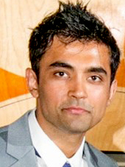 |  | Vaibhav Kumar is a medical oncologist and a clinical reviewed on the GI team. His research interests include assessing regulatory applications of Real-World Evidence and the development of clinical risk prediction tools to personalize care. In his spare time, he enjoys watching his beloved Arsenal Football Club, playing golf, and spending time with his family.

Michelle Olson is a medical oncologist and a clinical reviewer on the Breast, GYN, and Palliative Care team. She recently joined the FDA after serving 13 years in the U.S. Navy. In her spare time, she enjoys spending time with her son, walking her dog, reading, and traveling. . |  | 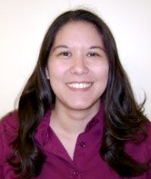

Interested in learning more about OCE?
Read our FDA Oncology Center of Excellence (OCE) Annual Report
follow us on Twitter @FDAOncology, or send us an email at FDAOncology@fda.hhs.gov

