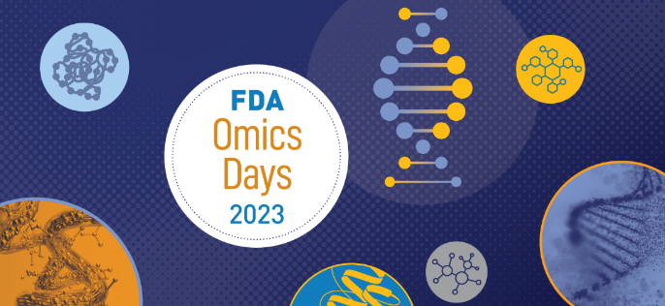

2023 FDA Omics Days: Poster Abstract Submission
Due on September 8, 2023

Primary Author’s Name: [Primary Author Name]
Primary Author’s Email: [Primary Author Email]
Author(s) Presenting will be first and list all authors as follows: First_name Last_name, Organization/Affiliation; separate each author with a semi-colon. Example: Homer Johnson, FDA/CTP; Edward Sanders, FDA/NCTR; Milhouse van Houten, NIH/NCI
[Authors]
Poster Title (Limit 250 characters. Do NOT use all CAPS)
[Poster Title]
Abstract (maximum 350 words and must include a brief method)
[Abstract]
Novel aspect/summary (maximum 50 words)
[Summary]
Which category BEST describes your subject matter area for poster placement?
Choose an item.

Will you be presenting your poster in-person? Please type Yes/No
[Type Yes/No]
If selected, are you willing to create a flash talk based on your poster that will be displayed at the Workshop and online? Yes/No
[Type Yes/No]
Survey Questions:
- What kind of class, seminar, or focus workshop would you like to see the FDA host?
[FDA Host]

- What do you consider a knowledge area within the agency that we should focus on for 2024?
[2024 focus]

- What are your interests within the omics space? (Enter all apply)
Such as: “FDA OneHealth”, “Genomics, Transcriptomics, Metagenomics", "Metabolomics, Proteomics", "Data Integration, Data Management"
[Interest]
Other: [Other Interest]
- Additional comments?
[Additional Comments]

