ADUFA Performance Dashboard User Guide

Current Performance (First Page)
The Current Performance page of the ADUFA Performance Dashboard shows the two most recent years of performance for each established goal, and the most recent year of performance for newly implemented goals established under ADUFA IV. When more than one year of data is reported, the first year’s data is final, and the second year’s data is preliminary with actions still pending.
The Current Performance page displays a stacked bar chart for each year of performance:
- The color of each segment of the bar represents status:
  - Blue represents actions completed “On Time,” or within goal;
  - Gray represents actions “Pending,” or within goal and where no action has been taken;
  - Orange represents actions “Overdue,” where action was taken after the goal date, or no action was taken and is past the goal date.
- Each bar is labeled with the number of actions in that status, except in cases where the volume of actions with that status is extremely small. In some instances, the label for the review status will not display in the graph due to space. This is an automatic default setting in the software. If you hover over the section of the graph where the label is missing, the label details will appear in the Tooltip.
- The “Performance Goal” is shown as a solid vertical line on the graph:
  - If the blue bar reaches the performance goal line, the goal status is “Goal Met”, or “Will Meet Goal”.
  - If the gray bar reaches the goal line, the goal status is “Currently Meeting, Pending”.
  - If the orange bar reaches the goal line, the goal status is “Goal Not Met” or “Will Not Meet Goal”.
In the example below, 347 submissions were filed in FY 2018. Of those submissions, 99% (345) met the performance goal, while 1% (2) did not. Since the orange bar does not reach the performance goal line, the status of that goal is “Goal Met.” In FY 2019, 353 submissions were filed; 57% (201) were on time, 42% (150) were still pending, and 1% (2) were overdue. Since the orange bar does not reach the performance goal line, the status of that goal is “Currently Meeting, Pending.”
Performance
Goal
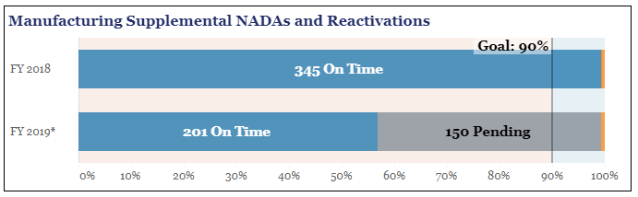
Fiscal
Year
To see a “tooltip” that displays additional information, hover the cursor over each status on a bar, as shown in the example below.

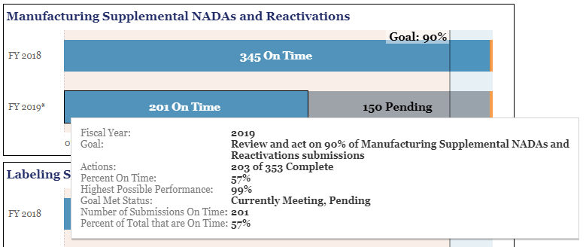

The tooltip provides several useful pieces of information. These include:
- Fiscal Year: The Fiscal Year of the receipt of the submission subject to the goal.
- Goal: The performance goal and type of action.
- Actions:
  - For final data, the number of actions out of the total that were on time
  - For preliminary data, the number of actions that are completed, regardless of whether they were on time or overdue, out of all potential actions
- Percent on Time: The percent of actions that met the goal
- Highest Possible Performance: The highest performance that can be achieved if all “Pending” within goal submissions are acted upon within goal.
- Goal Met Status: The statuses are “Goal Met,” “Will Meet Goal,” “Currently Meeting, Pending,” “Will Not Meet Goal,” or “Goal Not Met”
- Number of Submissions: For a specified status, the number of submissions included in that status
- Percent of Total: For a specified status, the percentage portion of submissions in relation to the total (100%).

Each Current Performance page has navigation buttons to the ADUFA Performance Home page and to a “Historical Performance” page showing the historical performance of the selected goal and a button to access the Dashboard User Guide. The ADUFA Performance Dashboard Home page also provides links to the “Historical Performance” pages.

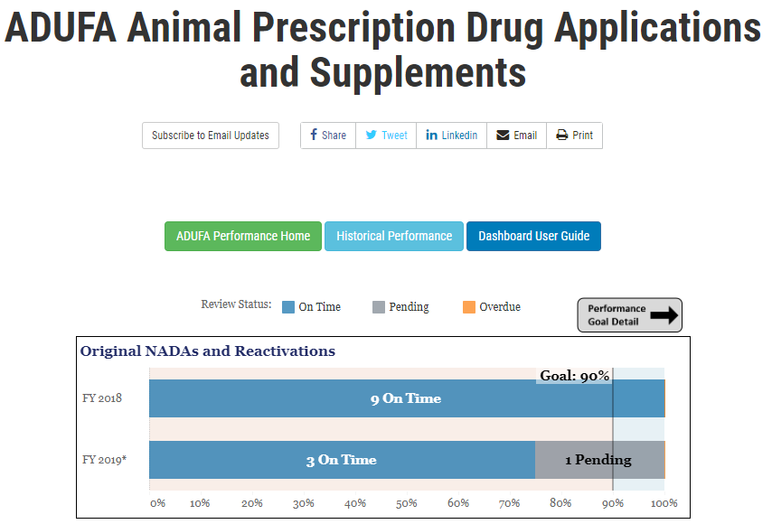

Historical Performance (Second Page)
The Historical Performance page of the ADUFA Performance Dashboard shows the past five years of data for each performance goal. The past four years of data are final and the past year of data, which may include newly implemented goals, is preliminary with actions still pending.
A drop-down list is provided at the top of the page that allows selection of a drug review goal for a given performance area as shown in the example below.

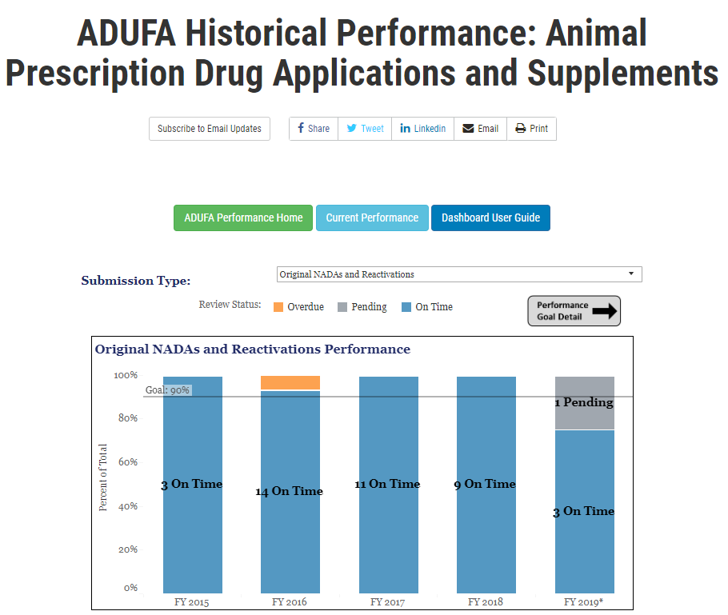

Workload data represents the number of submissions subject to the specific goals during the drug review process. The “average” line through the graph represents the average number of submissions over the six-year period.
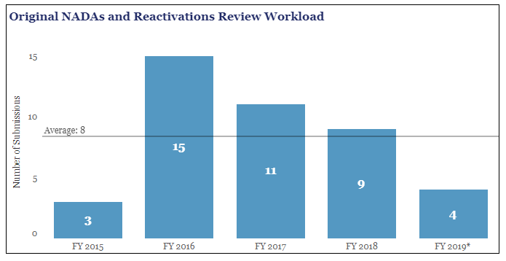
Navigation at the top of the Historical Performance page enables return to the ADUFA Performance Home page and to the Current Performance page as well as a button to access the Dashboard User Guide.

Dashboard data can be downloaded by selecting the “Download ADUFA Animal Prescription Drug Applications and Supplements Dataset” button under each dashboard, as shown below.
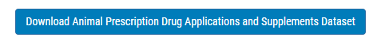

Footnotes are provided under each dashboard showing relevant information, for example, noting whether data is preliminary.
